

IFB299 IT Project Design and Development

Sprint 1 Personal Portfolio

Semester 2 2018

Due: September 21st 11:59pm

Weight: 15%

Student Name: Keonwoo Lee (IS student)

Student Number: n9353259

**Artefact1 – Meeting minutes for sprint 1**

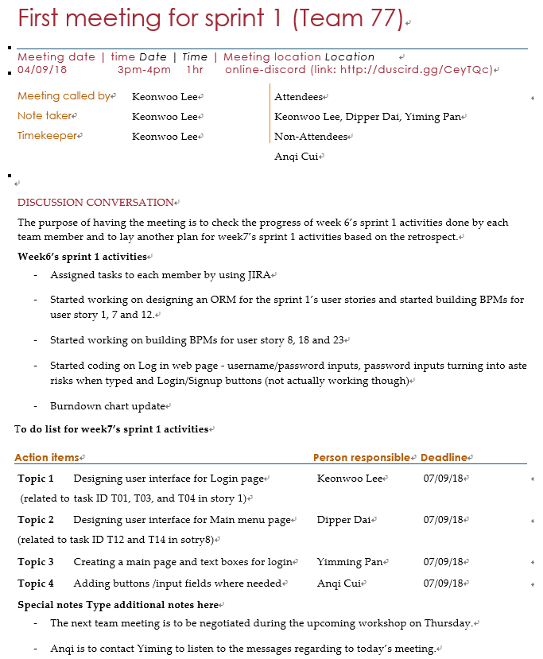In accordance with one of the scrum master’s roles, I have documented meeting minutes that describe meeting date and time, participants and non-participants, announcements, special notes, and discussion conversation which include what activities have been done so far and action items for each team member with respect to what activities we need to have done by what date for the upcoming week. Throughout the meeting minutes I have documented, our team could have more easily seen if every team member is on the same page and been well-informed of what to do for each week, in order to have certain contribution to the sprint 1 of the team project. The list below is the meeting minutes I have collected up to week 9 (20 days).

(Also available at: https://github.com/rocky310/IFB299-team-77/tree/master/Keon's%20folder/Meeting%20minutues)

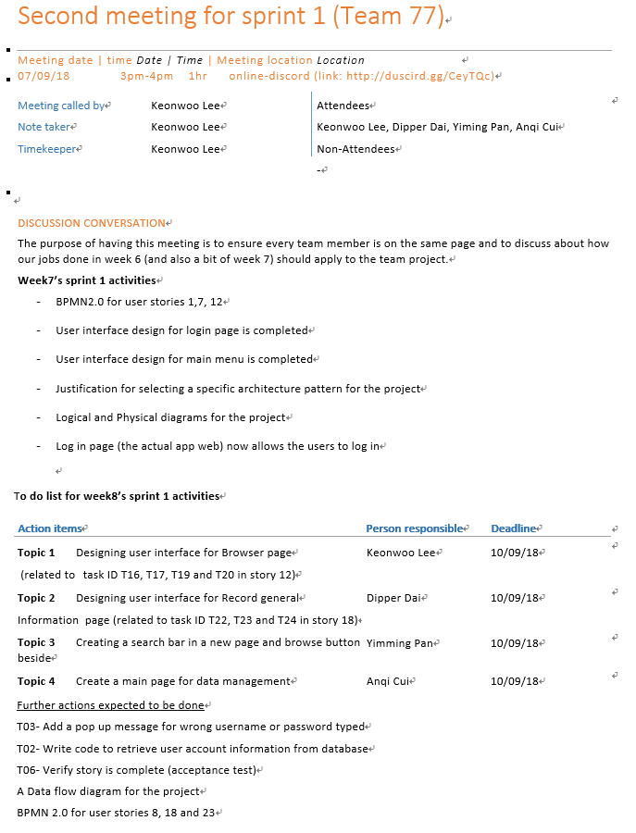

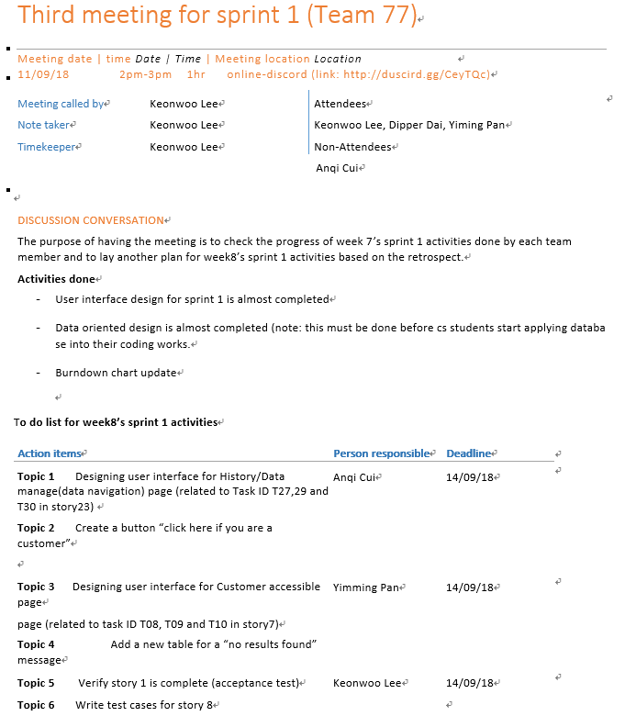

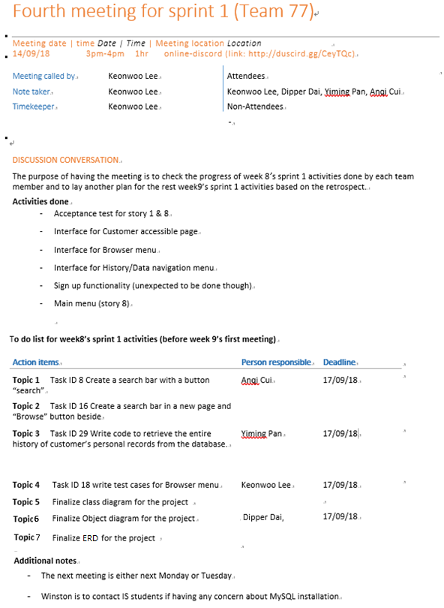

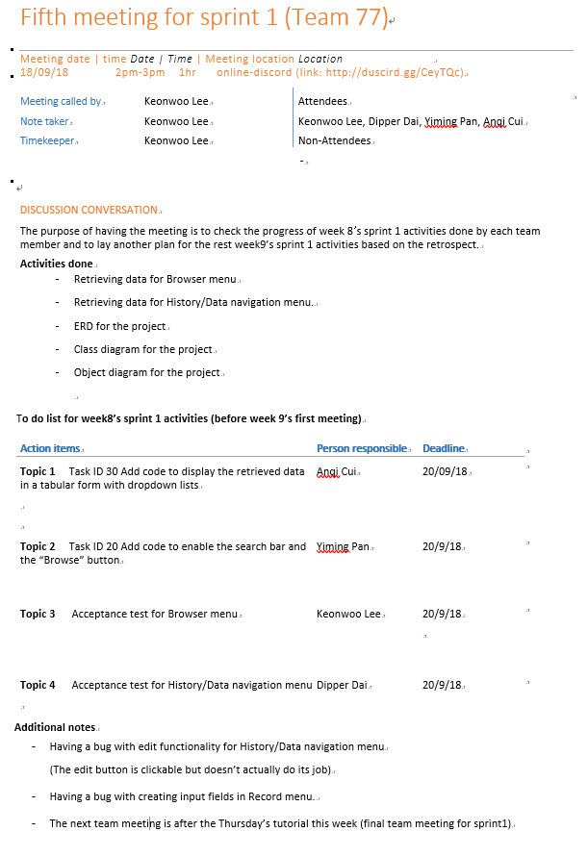

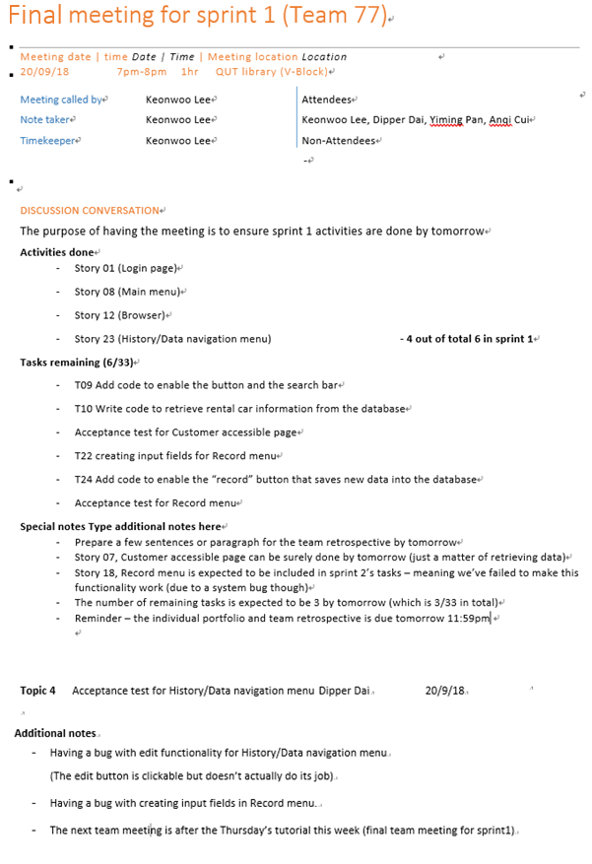

**Artefact2 – Data flow & Class Diagram**

The use of data flow and class diagram has significantly contributed to our team project, the coding processes in particular, as they describe interactions and behaviours between components that construct the central modelling of our project’s process aspects. Fundamentally, the data flow diagram successfully indicates how the data flow from one component to another in our software product, and class diagram is more about showing the relationship among classes and the overall design of our software product by describing the structure of the system with the system’s classes, attributes and operations, where a class refers to a template definition of the methods and variables in objects. These diagrams were finished designing and handed over to the computer science students (Anqi qui and Yiming Pan) before they started working on implementing database into our software product, in order for them to have a better understanding of what kind of data is supposed to be in what kind of functionality in our software product. The diagrams below are the Data flow diagram and class diagram I have designed, respectively.

(Also available at: <https://github.com/rocky310/IFB299-team-77/tree/master/Keon's%20folder>)

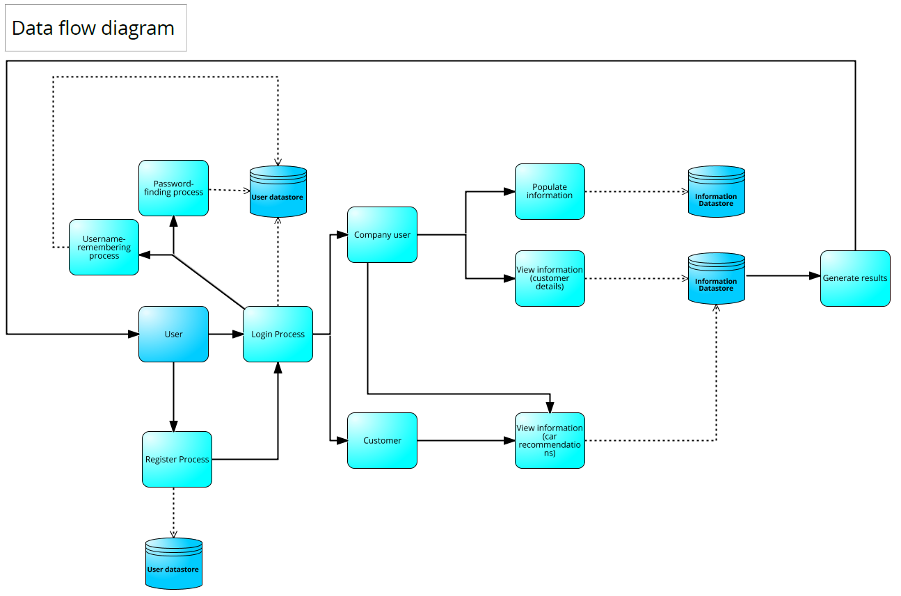

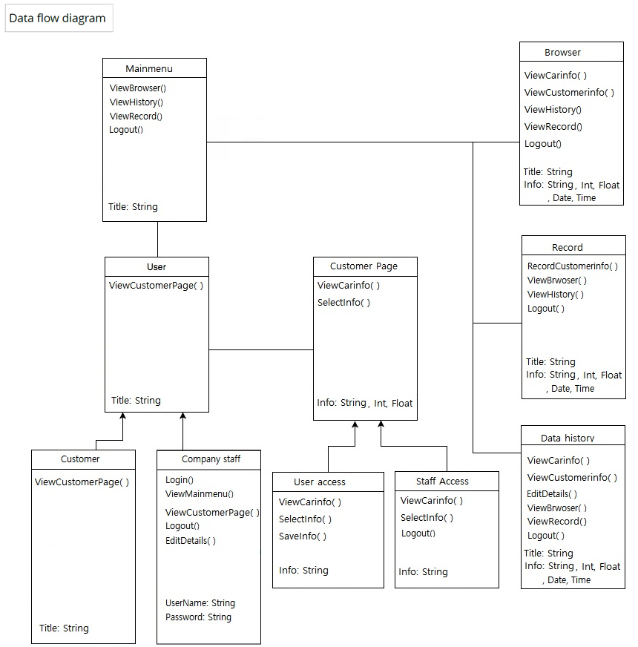

**Artefact3 – BPMN 2.0 (Business Process Model and Notation 2.0)**

A typical BPMN (Business Process Model and Notation) provides a software product with the ability of understanding its internal system procedures in a graphical notation and gives the software developers the capability to communicate these procedures in a standard method. This ensures that the software products will understand themselves and components in the internal system and will enable the software developers to adapt into new internal conditions quickly when needed. The BPMN I have designed is based on a flowcharting technique, and the ultimate goal of having BPMN in our project is to provide a standard notation readily understandable by all of the team members. Basically, I have designed 3 BPMNs (hereinafter BPM) for 3 user stories from the sprint 1 (half the total stories), which include the Login page, Browser page and Customer accessible page. Designing the other 3 BPMs were assigned to Dipper Dai, another information systems student in our team. The BPMs were designed with the general idea of user experience walkthrough to help the computer science students understand how each component of our software product would interact with one another as part of the CRC’s data management system process. The diagrams below include the 3 BMPs I have designed as well as the modelling conventions that explain what elements do what behaviours in the provided models. (Zooming through pdf files is highly recommended)

(Also available at: <https://github.com/rocky310/IFB299-team-77/tree/master/Keon's%20folder>)

**Modelling conventions**

|  |  |  |
| --- | --- | --- |
| **Element** | **Description** | **Notation** |
| **1.  Flow objects** | **Define the behavior of a business process** | |
| **Event** | **An event occurs during the course of a process, the events influence the flow of the process of how the token will traffic. There are 3 different types of Events, based off of when they affect the flow; Start, Intermediate, and End event. The Start Event triggers to call for the event. End Events explains the outcome of a process flow end path. Start Events can only respond to (‘catch’) a trigger. End Events can only create ‘throw’ an outcome. Intermediate Events can catch or throw triggers.** | |
| **Start event** | **The Start Event depicts where a particular Process will begin. It does not have any incoming Sequence Flows. It has to have at least one outgoing Sequence Flow. A Start Event may have 0 or more incoming Message Flows; each one is a stimulate for the Process. Only one of the triggers is essential to begin the Process.** | |
| None | The None Start Event doesn’t own a defined trigger. It represents for the start of an event that is being processed in CRC | **https://lh5.googleusercontent.com/oxxq77LsR0bl8lLlgvGLSgV_AoFV3l7E0pMnab1K1rRQg04wYix1l99VZ94P6mBPA48eBH86H63eqZSMviRcdoM2uku0CZE2r0WMYeFXO162CVTSyp2xhCA-OKAzLbHVr3C76HNz** |
| Message | The Message Start Event depicts a Message arriving from a Participant and activates the beginning of the Process. It indicates the start of an event that is being processed in CRC that is triggered by an incoming message, document or data resources that have been directed to CRC. | **https://lh5.googleusercontent.com/klGBtug_2Fx6zn42lVcTK_n-p3lWdtEpybj_GCjSOkSPwbrdF5E5prKONaIpr5FDCoeeTbKER9zQ8j86xe1jeRTkSSQhWPzIc0TXy-c1k7OGnYsEbj7Ooqpgpeh2S89FoT6BqkTI** |
| **End Event** | **The End Event represents for where a path of the Process will terminate. It has to have at least one incoming Sequence Flow, but must not include any outgoing Sequence Flows. An End Event must not attach any incoming Message Flows either. It can have 0 or more outgoing Message Flows; each one will have a Message sent when the Event is triggered. There may be more than 1 End Event in a single level of a Process.** | |
| None | The End event has no defined result. It indicates the end of an event or a process that has taken place in CRC resulting in a consequence | **https://lh6.googleusercontent.com/62aAEvC-AMJZnJZ0Swl6cYBZwrA_8q4yKt7NBNUOUusF9EU91KlL_ywdbGfmWNUvPZCGwRyfKRxYTz2PZTEjZk8TLl43C9sd5ALO8q1WZfSIrlNp5Zk6hETr_sHTeJQRu8-8kZEW** |
| Message | The Message End Event shows that a message is sent to a participant at the end of the process. It represents the end of an event or a process that has taken place in CRC resulting in a result with a message being sent out after the process has ended. | **https://lh6.googleusercontent.com/vmTINmHwyAv3gKXjoSgbHSjYZnVgvGiEzXDoLZjxIyzxW_9yIuAvFUzi9L2O7zT75FCzZepYUYi1HZFVLMpe4eN9FLc_Yz7yM-kcO08rY7SNkwb_n61knQOwWKofYeQvXZKd2sLR** |
| **Activity** | **An Activity is a standard definition for work that a system accomplishes in a Process. An Activity can have more than 1 incoming and outgoing Sequence Flows. An Activity can contain 0 or more incoming and 0 or more outgoing Message Flows.** | |
| Task | A Task represents an activity in a process. Normally, an end-user or an application is used to perform the Task when it is executed. | **https://lh6.googleusercontent.com/ap5PmryKvpVfeOLJ20LraIONGv9czU6f14Q3bQdn5-SOYeHvfbcHs7dOrH-IdUgbBvdJyjE27hXmHVCtM0JBUH-naCeNc7vzgUOGZVyU_aGz45luSbuGBklHKA2iV1iVS249ufkw** |
| **Gateway** | **A Gateway is for managing the divergence and convergence of Sequence Flows in a Process. The term ‘Gateway’ suggests that there is a gating mechanism that either permits or prohibits passage through the Gateway. Thus, it regulates splitting and linking of paths.** | |
| Exclusive  (XOR)  Gateway | XOR Gateway performs an EITHER-OR decision points and merges for a process. A separating Exclusive Gateway creates alternate path in a process flow when a decision is to be made through data. Essentially, only one path can be selected. | **https://lh5.googleusercontent.com/Kfis7HeiFRJhJoS4juzVGmYuEaPKafGbqpPBTDo8sYdtxwHfic8zkvurUt6Q1nxIpH1ScN-d2X4rOZiabh5ohREYdOrVqphGoC5FXG8i1Zv3-34dTtsml6dyWzDvJpVxnVG6HM6G** |
| **2. Data** | **Models the physical or information artefacts that are formed, operated, and used during the performance of a process** | |
| Data Object Reference | Data Object References can be used to show different states of the same data object at different points in a process. | **https://lh4.googleusercontent.com/S4zRrPPpEnQ4ENt9rdd8v4qXnlgNVG6QUkduHdJKrHRQBdxdlGZtHoOpm-5YeVexxAV6R58-qy9XEZx4kInDV57OIbHFDuDO0OcZ1ePUPYG5s2hD5NFX7jbvBlSfJlprs-ldnvIK** |
| Data Store | A Data Store delivers a mechanism for activities to fetch or update stored information. CRC uses data store to store data or to review data from them. | **https://lh4.googleusercontent.com/OVU8dVxSSO9LM6FVBHa9pt704ShJN6G0fLnsxoq8KEi-NoPMvChyRoi9wO1HX6Zr6BSzDeNC1w2ZR3Wh2OsGZBKTR3QWMlUYWZGp-3UUTxHJXQAyFuZigmm6GJ_I_wkEMBBZliTa** |
| **3. Connecting Object** | **Links Flow Objects to each other or other information** | |
| Sequence  Flow | A Sequence Flow indicates the order in which Activities will be performed in a Process | **https://lh6.googleusercontent.com/5B_tstcekUKDoHPOJQvs8iM8_-MZopvARiIB3kflG8D-rxBmg1phP0nj_NRrpVgrIuyq9gSImPe0YJm0GkcxqXwvOCvUNeReBwuEUecj3dGQNQTcr_qx0JPgTm5XiDrIhXRcOFFC** |
| Message Flow | A Message Flow indicates the flow of Messages between two Participants that are prepared to send and receive them | **https://lh3.googleusercontent.com/33H2IEkhSOmUvVUJQRUjzXjtioIVZ5GtKSmbD980FvNfocTZCMcXxTLKnhOK4rYghqhRUyRYIK1Uzcui7hCS_4rRc9FsppNOJELsNjqiNuuDi0aPTIGOEtXbm6LJfE2xL5wCF5ZW** |
| Data  Association | Data Associations indicate the flow data among Data Objects | **https://lh5.googleusercontent.com/OAPejJp6_fQOHoHz6Zj1nW7q53LV1-YjOhkug4QekQd4m4X9wXYVa3RohKcTX6OUsM41i0sCyCsTsAKLXYMQ7kKR9RZbhF3HD7VXy67pWUtp8igP9ej4H_VQPiTAFwEplcmcZbYw** |
| **4.Swimlane** | **Groups elements** | |
| Pool | A Pool is the graphical illustration of a Participant within the system | **https://lh3.googleusercontent.com/aqC2HhBuSjOEVQeLXjzSecHFtd6fELg6yWKZdIVVs_NgnyPudRNvitZBSuJWW29MEXuY8Mfj6uVf6CBdrNPx8Jf5nXBKFzuMlm7XRE0qGAJ6AvE5JobLun_DN8sPJGK105sjQ2rZ** |
| Lane | A Lane is a sub-partition within a process and will spread straight the entire length of the Process. Lanes are used to organise activities. | **https://lh5.googleusercontent.com/3FgBYWyzABSBkpjlub_XrxBFBDnM48bksIwv8HFBWeLyFqAeeWEzqdTeuYT8e2O7lvAQgc4q7ZfBQT95o3KcAcUzrQQuINP-pKmalrWXBRhmwVGrVHTsL4ZOopai0Rd1O_-As2wE** |

**BPMs**

1. 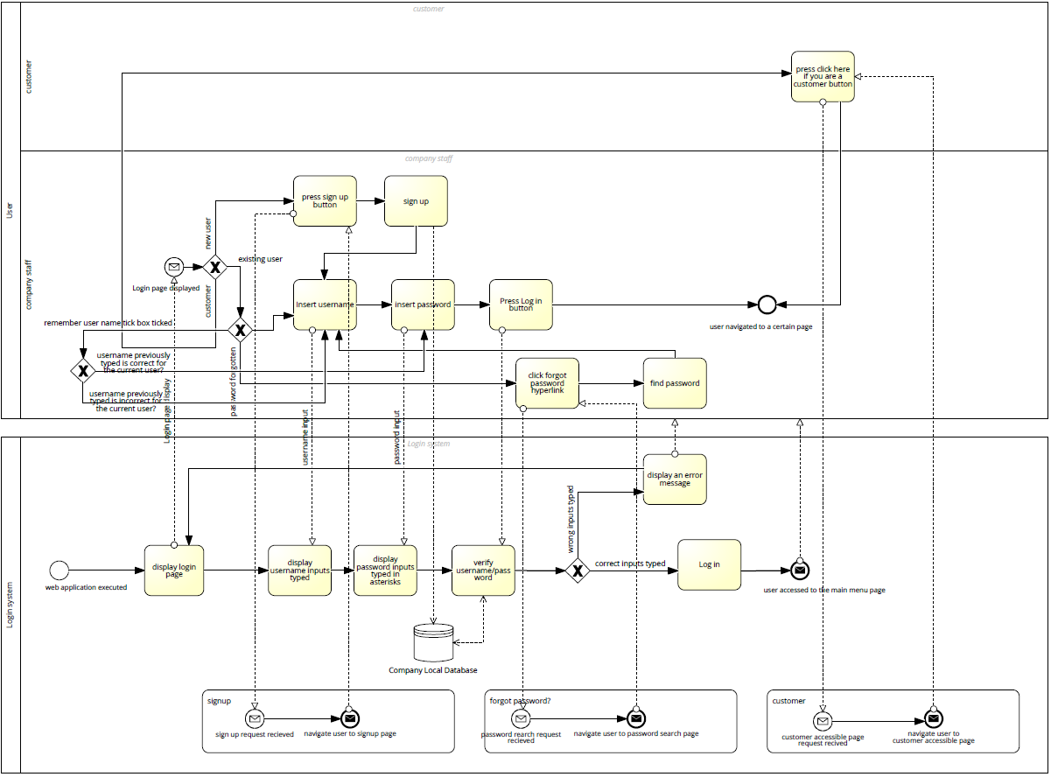**Login**
2. **Browser**

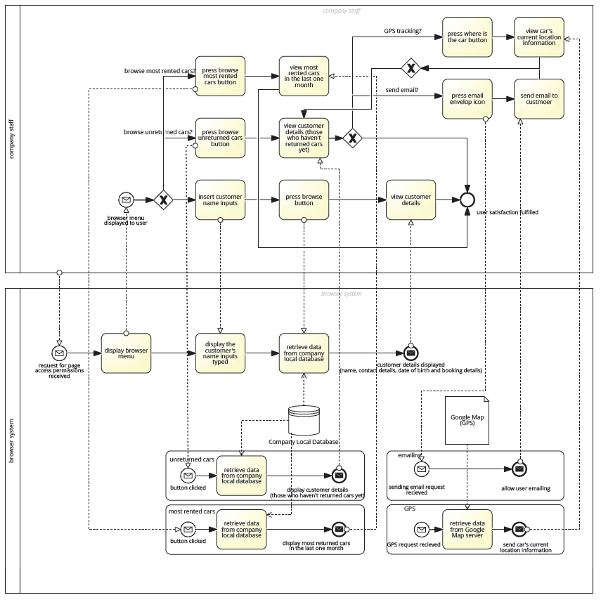

1. 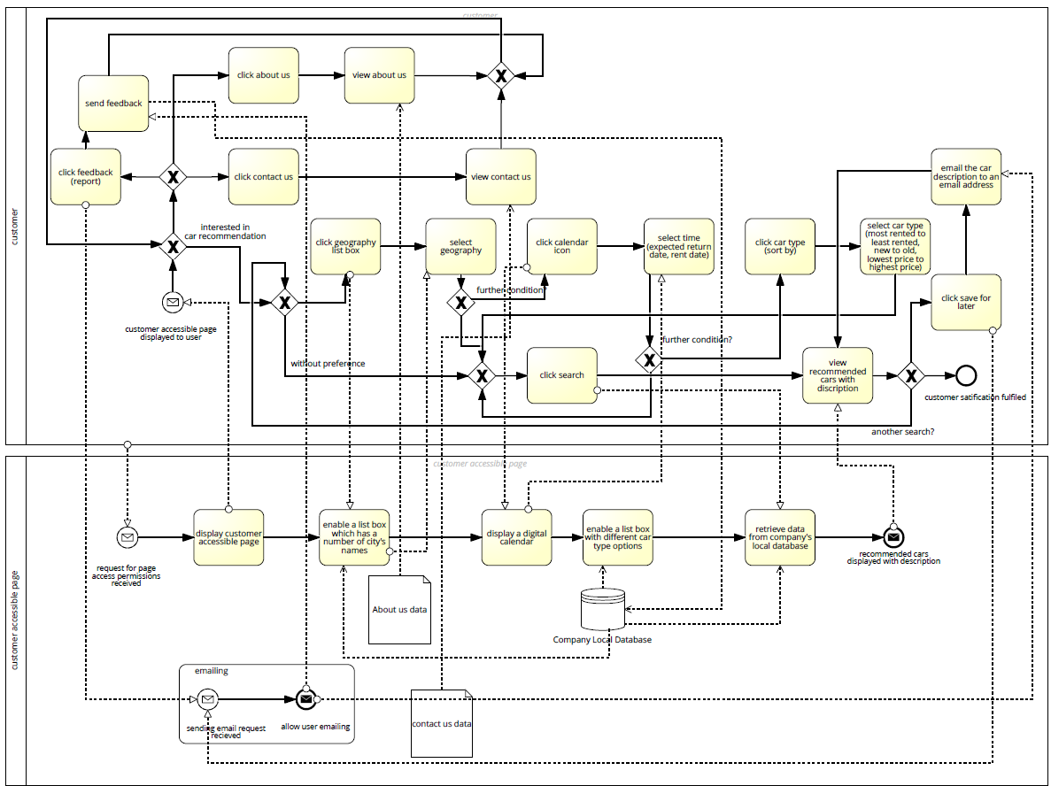**Customer accessible page**

**Artefact4 – Graphical user interface design**

A few graphical user interface designs have been also done for better understandings of what the functionalities required by the user as well as the overall external aspects of the proposed software product would actually look like when finalised. Additionally, the designed graphical user interfaces could suggest some quality attributes of the software to the developers, that include simplicity, manageability, conceptual integrity and feasibility, which our team had to consider when starting doing the sprint activities in a proper way. By having some graphical user interfaces designed first, we were able to estimate whether our sprint plan would be actually feasible to run at a certain degree, and we discovered some limitations as well based on the conceptual framework established throughout the design processes. The graphical user interface designs I have come up with is associated with certain contributions to the tasks with Task ID 01, 03, 04, 05, 16, 17, 19 and 20 of our first sprint plan, which then refers to Story 1: Log in page and Story 12: Browser menu. The Marvel mock-up website was used as a designing tool during the process of graphical user interface designs. (Aslo available at: <https://github.com/rocky310/IFB299-team-77/tree/master/Keon's%20folder>)

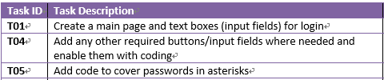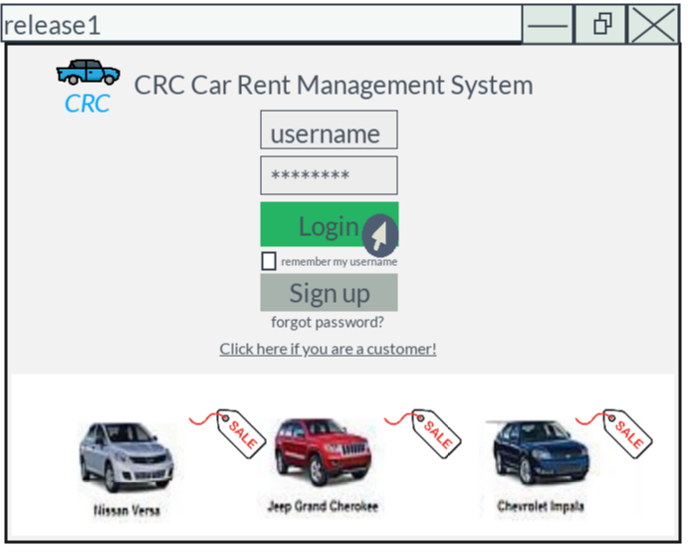**Login page**

**Login page – wrong username/password typed**

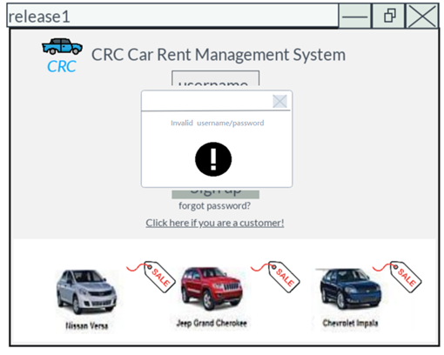



**Browser menu**

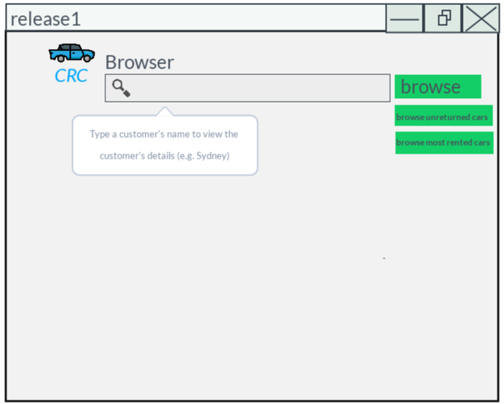



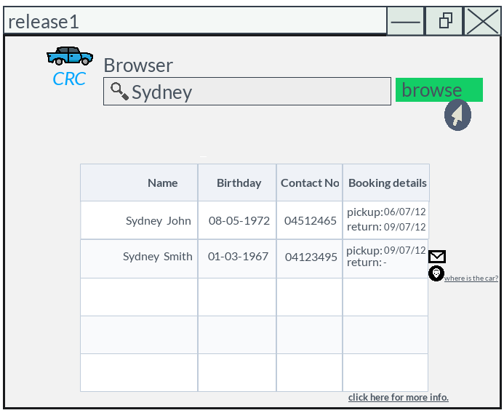**Browser page – with results found**



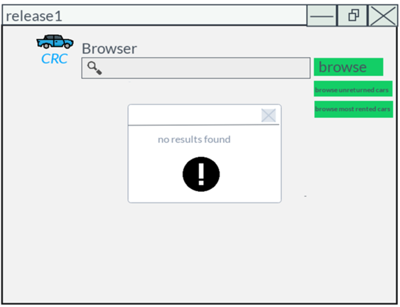**Browser page – with an error message**



**Artefact5 – Acceptance test (verifying story is complete)**

In accordance with fulfilling the tasks with task ID 6, 11, 15, 21, 25 and 31, which all refer to verifying story is complete, acceptance testings have been performed to govern whether or not our software produc has met the acceptance criteria that had been identified during the period between Week1 and Week6 of planning the user stories. The main aim of having the test done even after sprint 1 is over is to evaluate the system's conformity with the requirements suggested by the clients and verify if it is has encountered with the essential criteria for delivery to end users**.** It is also highly expected that the acceptance test will help the team better work on the upcoming activities of sprint 2 throughout the retrospect established within the previous works. The acceptance test is described in a tabular format as described below.

1. **Table**

|  |  |  |  |  |  |
| --- | --- | --- | --- | --- | --- |
| **Story ID (No.)** | **Story Description** | **Expected outcomes**  **(Acceptance Criteria)** | **Actual outcomes** | **Expected Hours(h)** | **Actual taken hours(h)** |
| 01 | Login - The company staffs will be able to have access to the main menu by login with their own signed up password and username. | -A neat and clear interface  -Allowing the user to login with a previously set username/password (no sign up at this point)  -Covering passwords in asterisks  -An error message text box popping up when wrong username/password typed | - All the requirements are met but a bit differently to our expectation  - An error message text box doesn’t pop up, but instead it is instantly displayed on the current page  - The sign-up and logout functionality wasn’t expected to be done, but was essential to fulfil the tasks of the given story | 8 | 6 |
| 07 | The customers will be able to have access to the web application even without logging in, and to view car recommendations based on their conditions | -Allowing user to have a certain access to the system without logging in  -Allowing user to view some car recommendations | -The user does have the access to a page titled ‘Customer accessible page’ by clicking ‘click here if you are a customer’, but is not able to view any car recommendations. Retrieving car info isn’t an issue, but we thought we should rather first combine the data retrieved with some images of actual car designs, which is a task of sprint 2 activities | 6 | Uncompleted |
| 08 | The company staffs will be able to have access to the main menu by a simple login | -Allowing the user to move to different menus by clicking different navigation patterns provided by the page | - The requirement is successfully met, and It didn’t take too long to fulfil the task | 5 | 3 |
| 12 | The board of CRC will be able to browse particular information by typing inputs in the input field provided. | -The browser menu searches for a particular customer’s info or car’s info by typing a certain input into the input field and click Browse button  -Certain types of information are loaded up | -Every requirement is met  -However, the system shows every information it has from the database even before clicking Browse button  -A button with a + sign can load more detailed information other than the originally provided ones | 9 | 7 |
| 18 | The company staffs will be able to store particular information using blank inputs fields and some functional buttons provided. | -The page contains some input fields and the company user can save particular data using those input fields and clicking record button | -None of the requirement is met since we had problems with applying elements, such as input fields into the database | 5 | Uncompleted |
| 23 | The management staff will be able to manage (navigate, edit, delete and load) all the collected data. | -The page displays the entire information data of CRC in a tabular format | -Better than what we expected, the data dimensions are displayed in a nice manner.  -We also succeeded in providing Edit button (which doesn’t work for now though and is a task of sprint 2) | 7 | 7 |

1. **Screenshots**
   1. 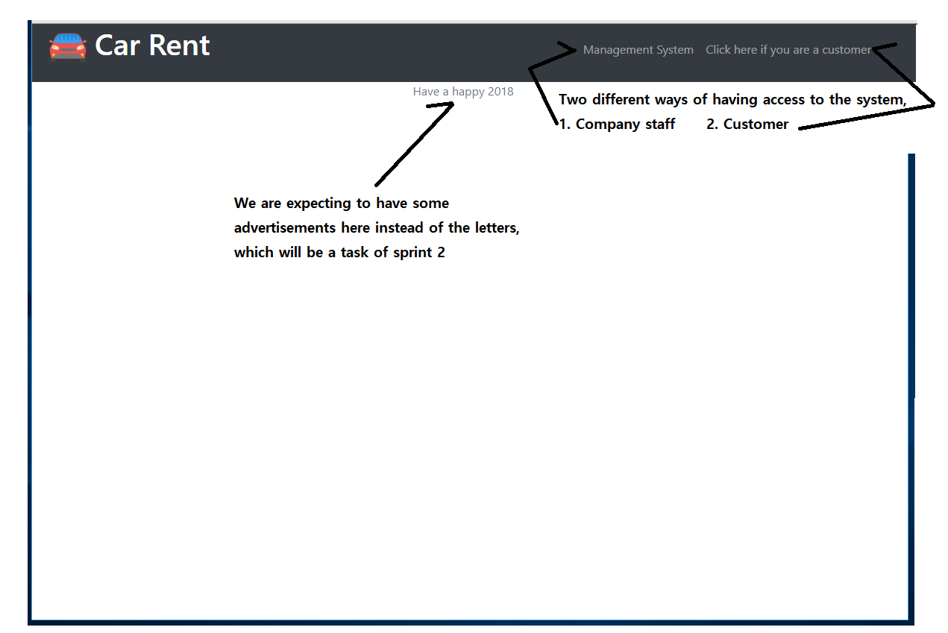**Welcome page**
   2. 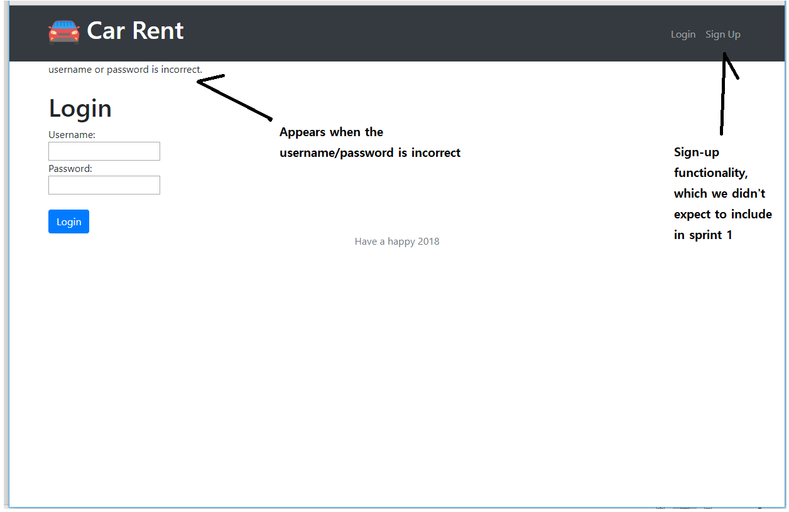**Login page**
   3. 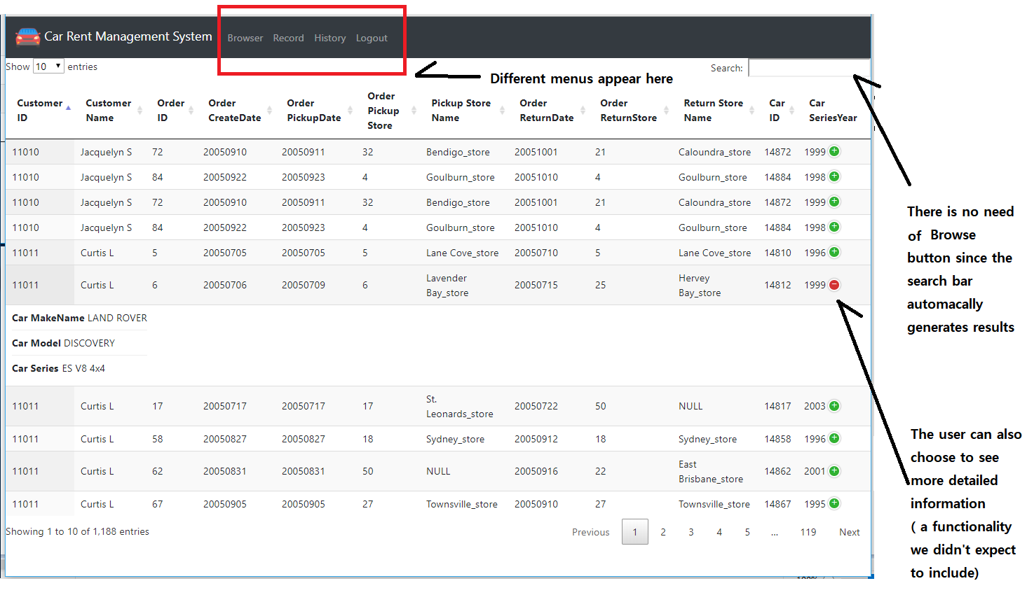**Browser menu**
   4. 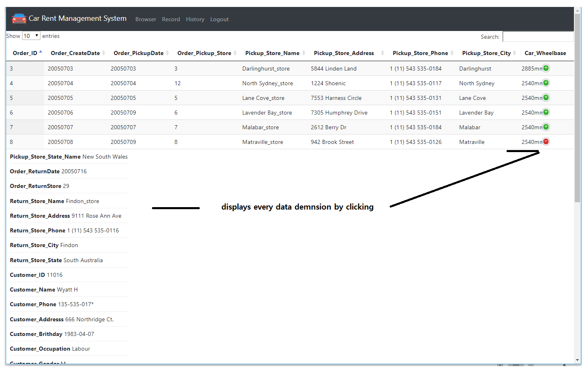**History/Data navigation**
   5. 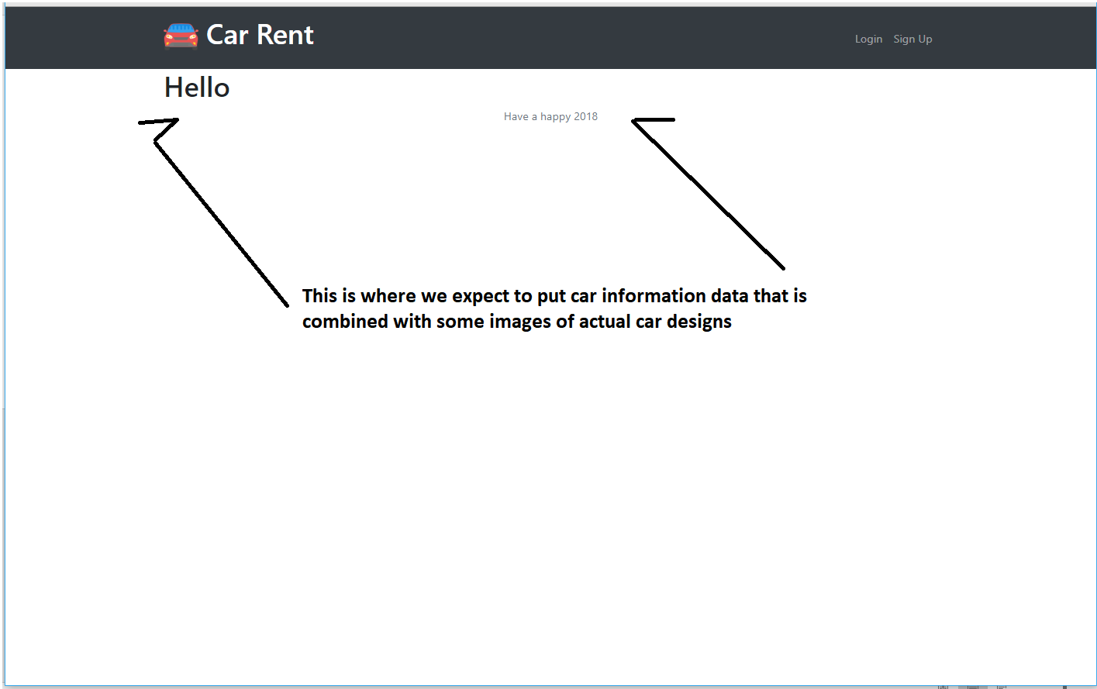**Customer accessible page**

**End of page**